A RGB image can be think of as 3 images in one, because here each pixel contains 3 values one for each Red, green and blue, so we can say that there are 3 n\*n matrix containing value from 0-255 one for each R, G, B. These 3 matrix or these 3 color format are called channels

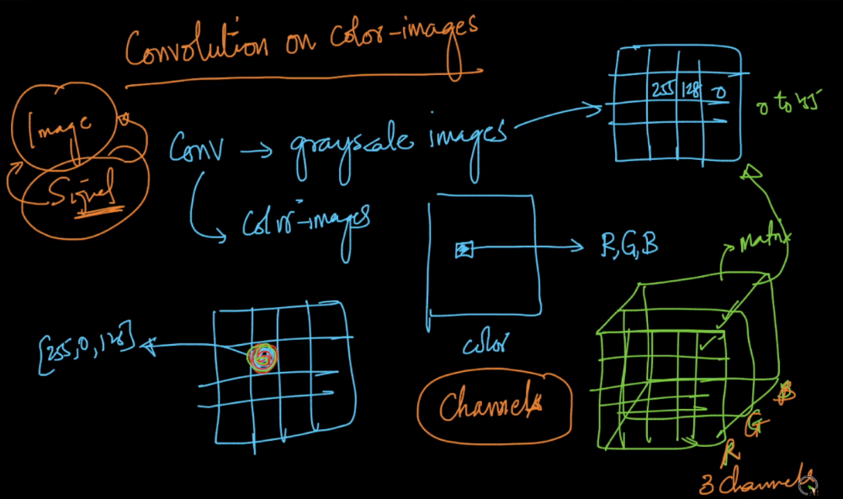

We can say that RGB image as 3D-tensor, whose dimensions are n\*m\*c where c is channel, therefore for RGB image c=3

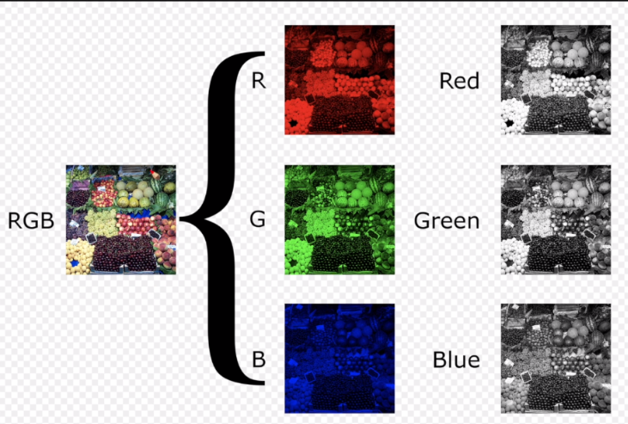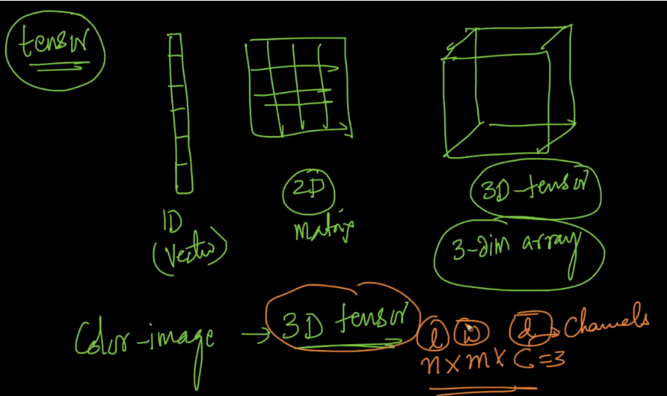

For performing convolution on 3D/RGB image, the kernel will also be 3D of dim k\*k\*c, where c is channels present in an i/p image.

For performing convolution we’ll move a kernel(3D/cuboid) on i/p image(3D/cuboid), and we’ll do the multiplication of each respective cell value and then add all the values, even of all the channels, so for each move we get 1 value. That means the o/p image will be 2D of dim (n-k+1) \* (n-k+1).

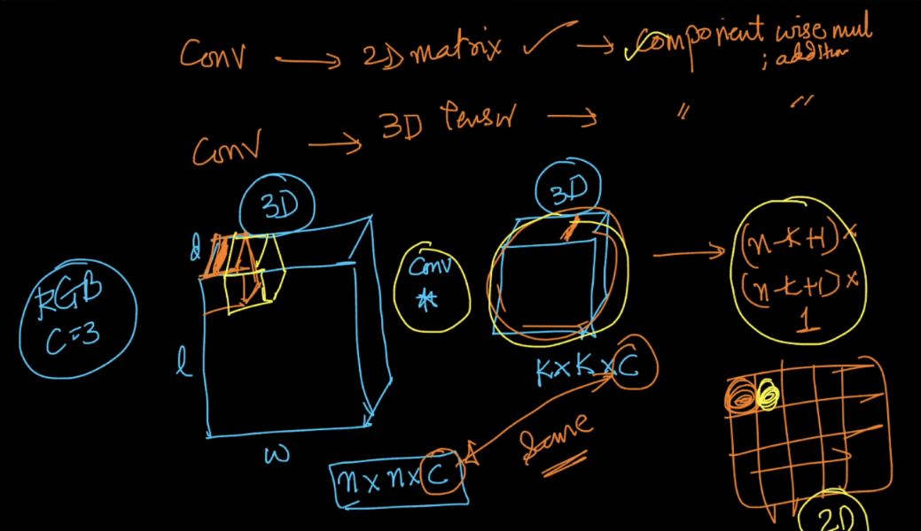

All the formulas that we have earlier for greyscale images will remain same for RGB also, except channel(c ) will be added to i/p and kernel.

